Civil War Map Analysis
Compiled by Earnestine Sweeting
esweeting2@schools.nyc.gov

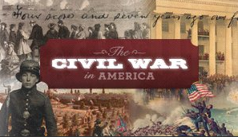 | The Civil War in America Exhibition  http://myloc.gov/exhibitions/civil-war-in-america/pages/slobjectlist.aspx  http://myloc.gov/Exhibitions/civil-war-in-america/Pages/teacher-workshop-resource-material.aspx
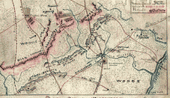 | Plan of the Battle of Wilderness  http://www.loc.gov/item/CABIB20007469  http://www.metmuseum.org/exhibitions/view?exhibitionId=%7b9400F95D-89A4-4920-A05E-46EE3CEDC9C0%7d&oid=190061072&pg=3&rpp=20&pos=1&ft=*
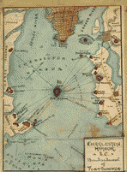 | Charleston Harbor S.C Bombardment of Ft. Sumter  http://www.loc.gov/item/CABIB20008522  http://www.metmuseum.org/collections/search-the-collections/190057120
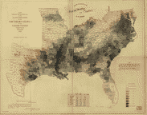 | Distribution of Slavery  http://www.loc.gov/item/99447026  http://www.metmuseum.org/exhibitions/view?exhibitionId=%7b9400f95d-89a4-4920-a05e-46ee3cedc9c0%7d&oid=190056997&ft=*&fe=1
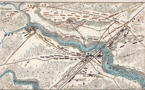 | Plan of the Battle of Bristoe Station  http://www.loc.gov/item/CABIB20007397  http://www.metmuseum.org/Collections/search-the-collections/190019895
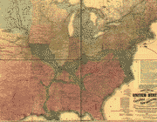 | Lloyd’s new map of the United States…showing every railroad  http://www.loc.gov/item/98688332  http://www.metmuseum.org/Collections/search-the-collections/190019895
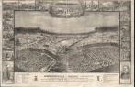 | Andersonville Prison, Camp Sumter, Ga.  http://www.loc.gov/pictures/item/2006685447/  http://www.metmuseum.org/exhibitions/view?exhibitionId=%7b9400F95D-89A4-4920-A05E-46EE3CEDC9C0%7d&oid=190057047&pg=3&rpp=20&pos=42&ft=*
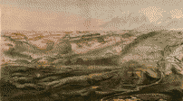 | Gettysburg battle-field  http://www.loc.gov/resource/g3824g.cw0322000/  http://www.metmuseum.org/Collections/search-the-collections/90095947
loc.gov/teachers
Library of Congress Teachers Page
loc.gov/teachers

