Name _____________________________________ Date _______________
IT’S YOUR TURN! – Visions of Rural America, 1830s
Shown here are two images of rural America by William Sidney Mount. Each image depicts a different aspect of rural life in Suffolk County, Long Island. Complete the chart on the next page using the details from each painting. Use the lines beneath each picture for notes.
The Sportsman’s Last Visit, 1835
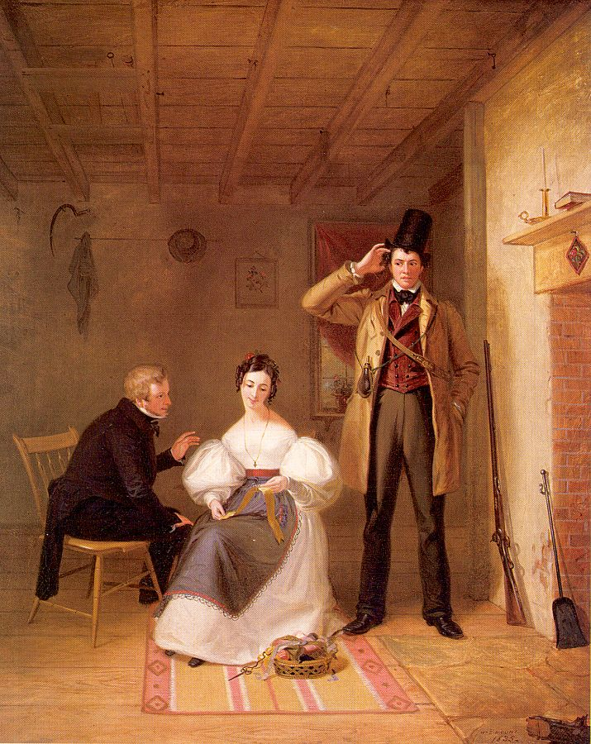
Notes:________________________________________________________________________________________________________________________________________________________________________________________________________________________________________________________________________________________________________________________________________________________________________________________________
School Boys Quarreling, 1830
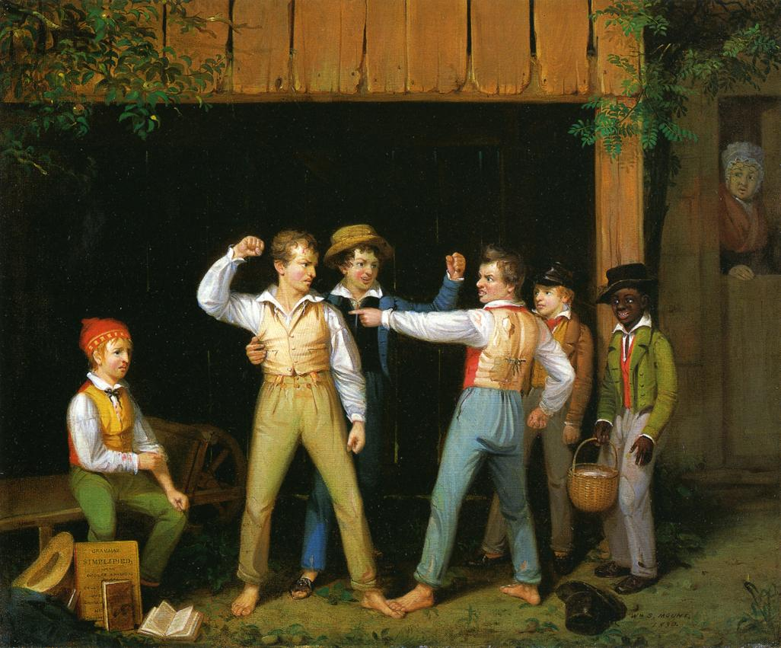

Notes:________________________________________________________________________________________________________________________________________________________________________________________________________________________________________________________________________________________________________________________________________________________________________________________________

The Sportsman’s Last Visit, 1835 School Boys Quarreling, 1830
1. Describe the central characters in the painting and explain what they are doing.
2. Write three words that describe the mood of the painting.
3. What does each painting tell us about rural life in Long Island in the 1830s?
4. Support your answers above with relevant details from each painting.

